Program to print details of a Car from Class Vehicle: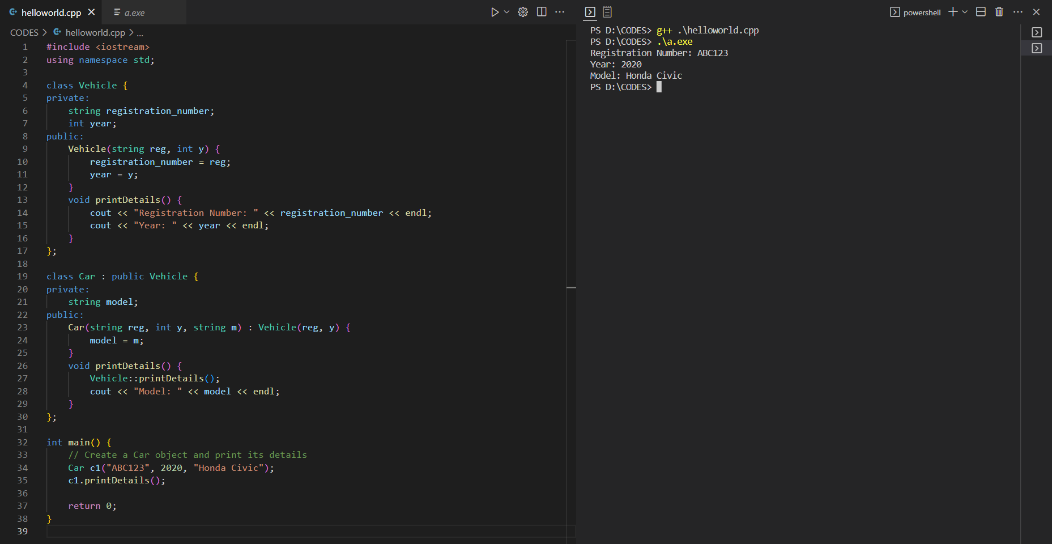Program to create class Vehicle and print details of a car from it: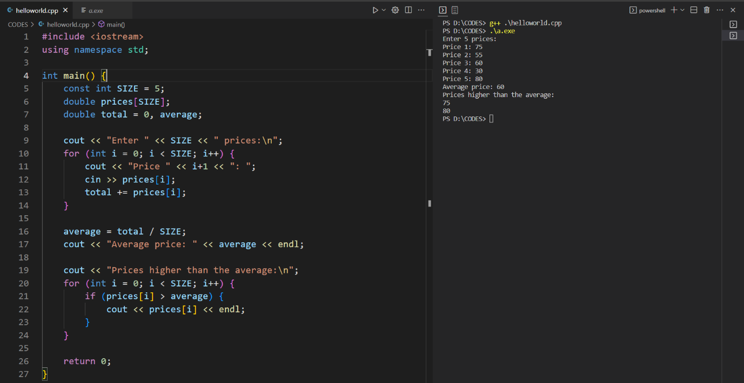Program to calculate average of prices and those who are higher than average:Program to perform various operations on a string:
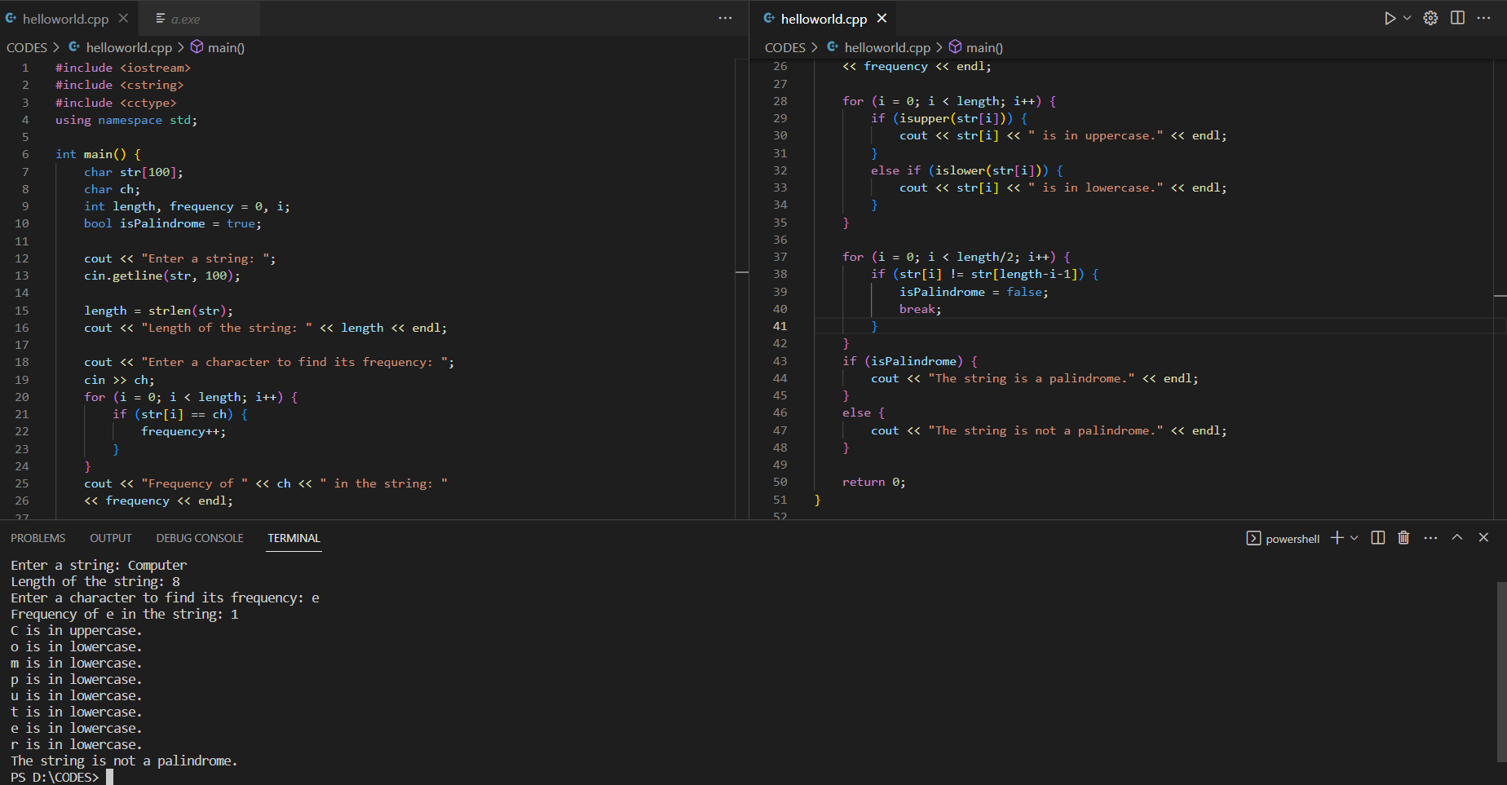
Program to print the series and its sum: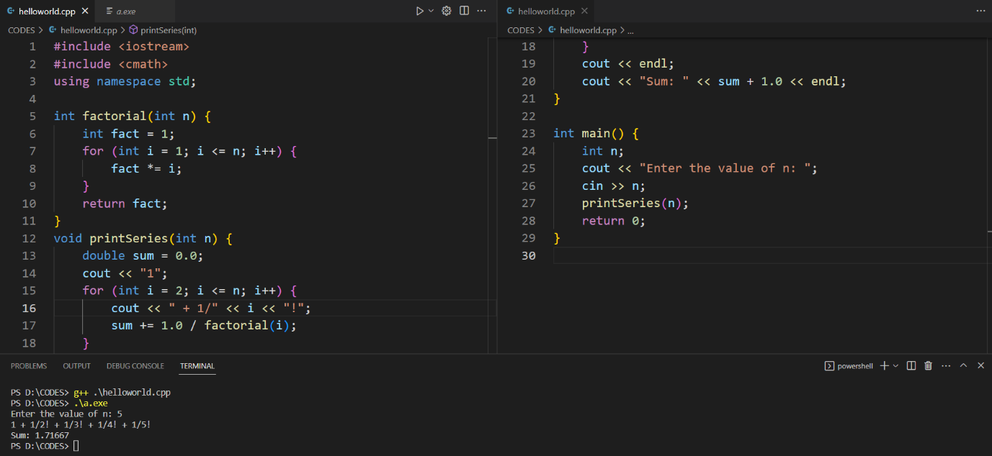Program to reverse a number, print it and print the sum of digits: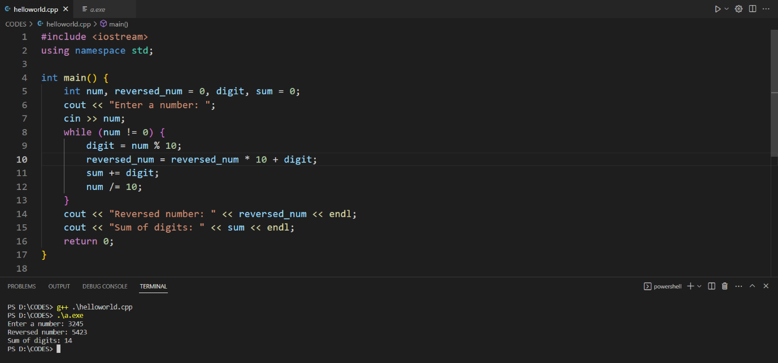
A menu driven program: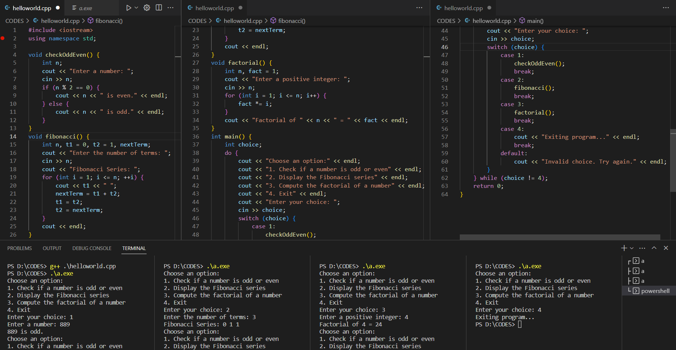Program to take n number and print the lines with ‘*’: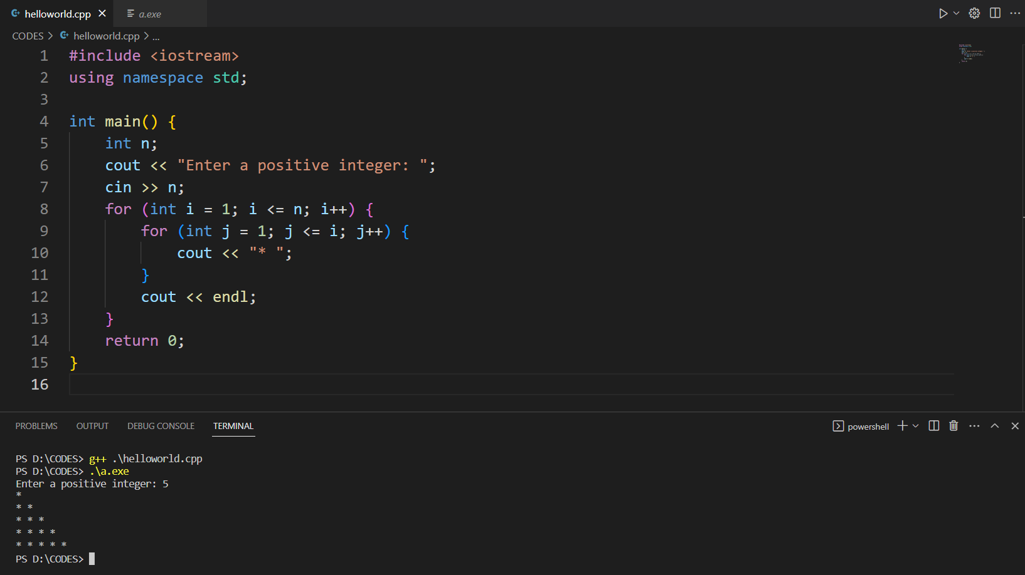
Program to find if the number is prime or not: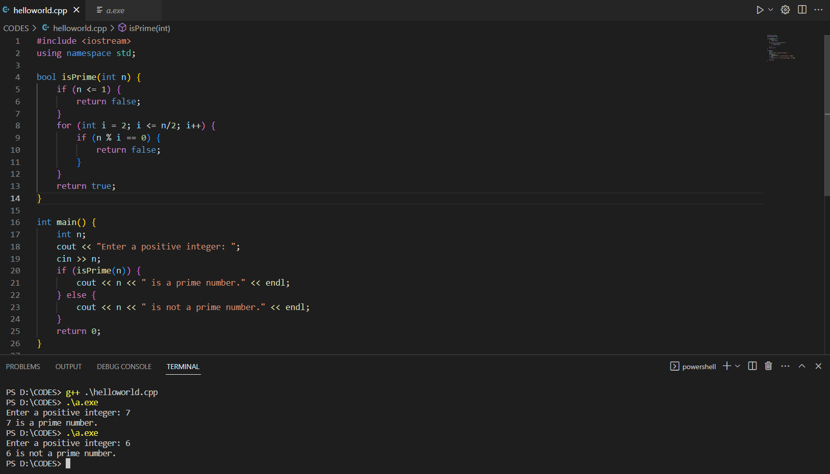Program to find the largest of n natural numbers: